RMI Assignment

John Cummins

16373731

**Description of the system:**

**Client side:**

**Client Class:**

The system starts once the rmiregistry command is run, then the server is kicked off with the start-server.sh script, “ExamEngine bound” is then displayed in the command prompt to symbolise the server has started. Once the server has started you can start the client by running the start-client.sh script, once the client script has been run, the client class locates the registry and connects with the server. The security manager is also initialised once this class is run, once the security manager is set up a method called LoginNow is called from the Login class.

**Login Class:**

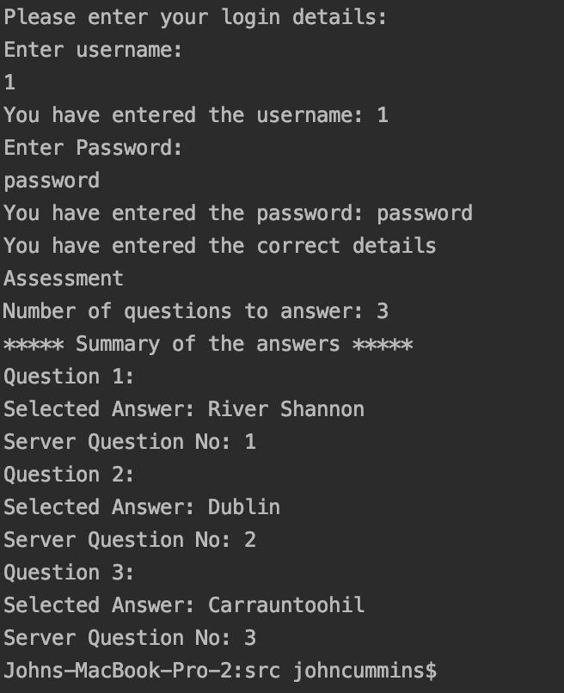The login class has two functions, the one which was previously mentioned, is the LoginNow class, this class contains a scanner, which waits for the user to input their userId and password into the command prompt. Once both the userId and password have been entered then these details are passed to the other function in the Login class which is called VerifyUser. This function takes in both the userId and password and compares it to array of students from ExamEngine in order to see if there is a match, if there is a match then the user gets logged in and a message is displayed in the command prompt saying you entered the details correctly. Once the user is logged in s gui pops up containing the assessment relevant to the course code, attached to the student.

* This is a screenshot of the password and User command promt entry:

**AssigmentOptions Class:**

This class takes care of all the gui stuff for the users assessment, three questions will be displayed on either Geography or Maths, depending on the course codes. There are three possible answers to each question, once the user picks their answers they can submit them to the exam server by clicking the submit button in the gui.

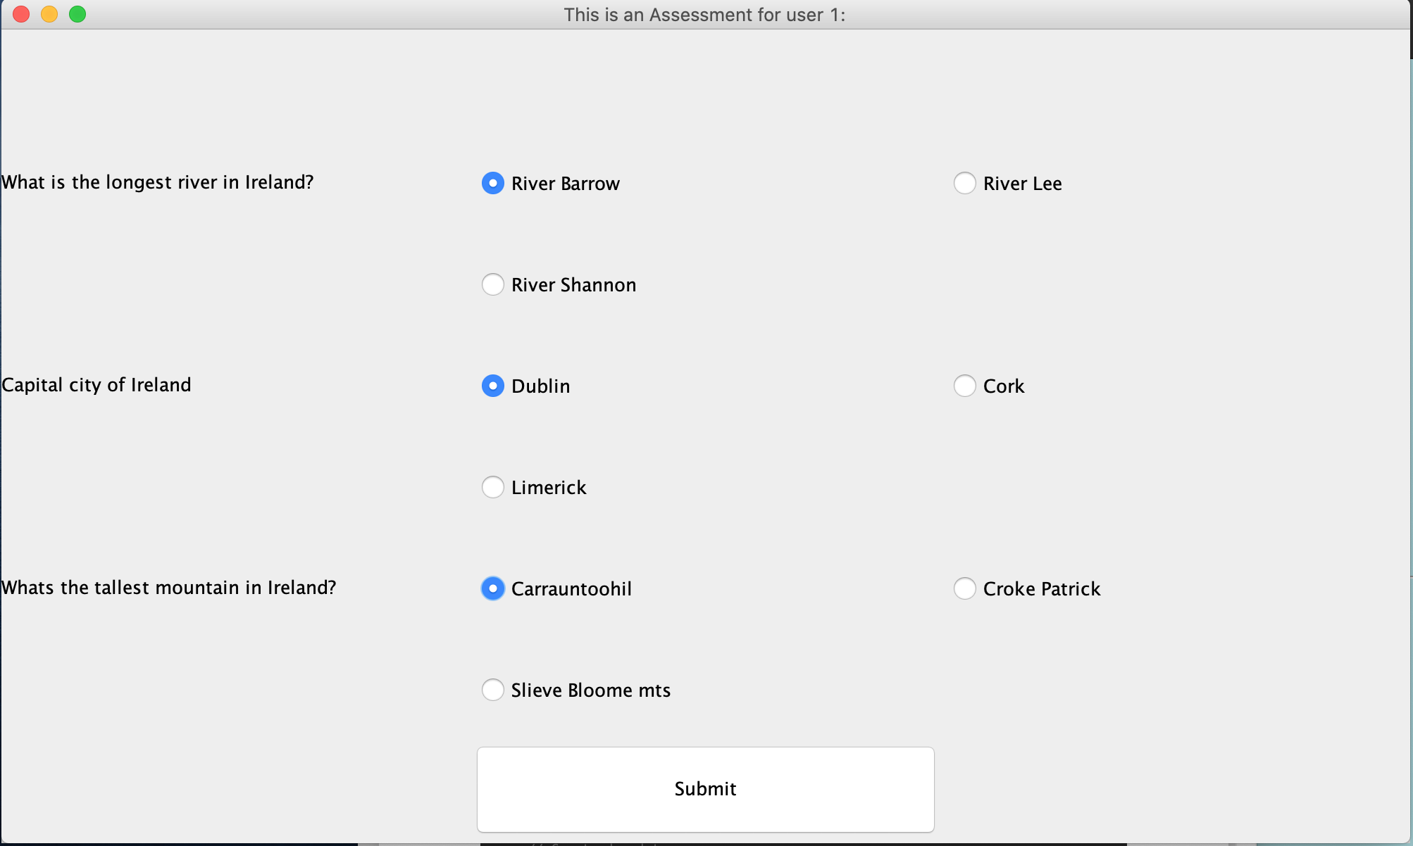This is screenshot of how the gui looks:

Once the user has selected answers, they then hit the submit button, which stores the answers to each question. A message then pops up in the gui saying they have submitted the assessment. The user can then see a summary of their answers in the command prompt, as shown in the below screenshot:



**Server Side:**

**Exam Engine class:**

On the server side the examEngine class takes care of most of the work.

Firstly the createToken function, creates tokens, which are used by the user to login. These token are assigned to the user in the login function as mentioned previously, where the a list of students are stored and the verified users are the students that are stored in this array, these students are created in the Test class. The getAssessment function in this class is responsible for retrieving the students assigned assessment and returning it so it called in the Assignment class.

SubmitAssessment function is responsible for submitting and saving the assessment. The findStudent function displays the user id and current token associated with that user in the server command prompt. The setupTest function calls the Test class.

**Test class:**

This class is responsible for the creation of the questions and answers and the assignment of these questions and answers to the relevant assessment. This class also creates the students, by assigning a id and password to each student.

Server side command prompt: